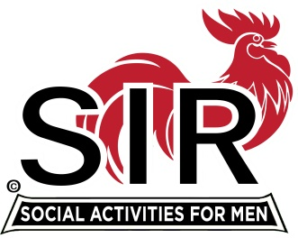
Las Trampas Branch 116
BEC Meeting Agenda
January 17, 2022, 8:30 AM via Zoom
[Zoom login at the bottom of the agenda]
The Mission of SIR is to enhance the lives of our members through fun activities, events and luncheons – while making friends for life.

8:30 am Call to order; Secretary, Paul Ramacciotti, confirm a quorum and Approval of Dec 20th, 2021 and Jan 7th 2022 BEC meeting minutes
8:35 Treasurer - Alan Fitzgerald - Report 2021 Year end budget
8:40 Standing Reports
- Membership – Phil Goff
- RAMP Department Head Reports:
- Recruitment, Don Schroeder
- Activity Coordinator Mike Ward (potential new activities?)
- Member Relations (open)
- Publicity Al Farbman
- Covid Compliance - Kevin Donahue (should we update DB with boosters?)

8:50 Proposed Branch Goals for 2022 – Big Sir, Fred Wachowicz

9:20 Proposed Branch Budget for 2022 – Treasurer, Alan Fitzgerald

9:30 Little SIR Updates – Roger Craig
Speaker Update
Birthday Boys
9:35 Old Business -
Boundary Contract and Pricing – Alan Fitzgerald and Mike Schneider
9:40 New Business - Fred Wachowicz
Covid Updates
February Meeting (in-person or Zoom or other lunch options)?
Assess covid impact, if any, on Branch indoor activities?
Annual Audit Plan – Ron Armijo
10:15 am Adjourn; Next BEC Meeting February 21st, 2022

Zoom Invitation

https://us02web.zoom.us/j/89269854543
Meeting ID: 892 6985 4543
Passcode: 826904
Dial-In: (669) 900-9128

